Part 1 Step 1. Install a MySQL server, and create a new database named “crowdfunding_db”

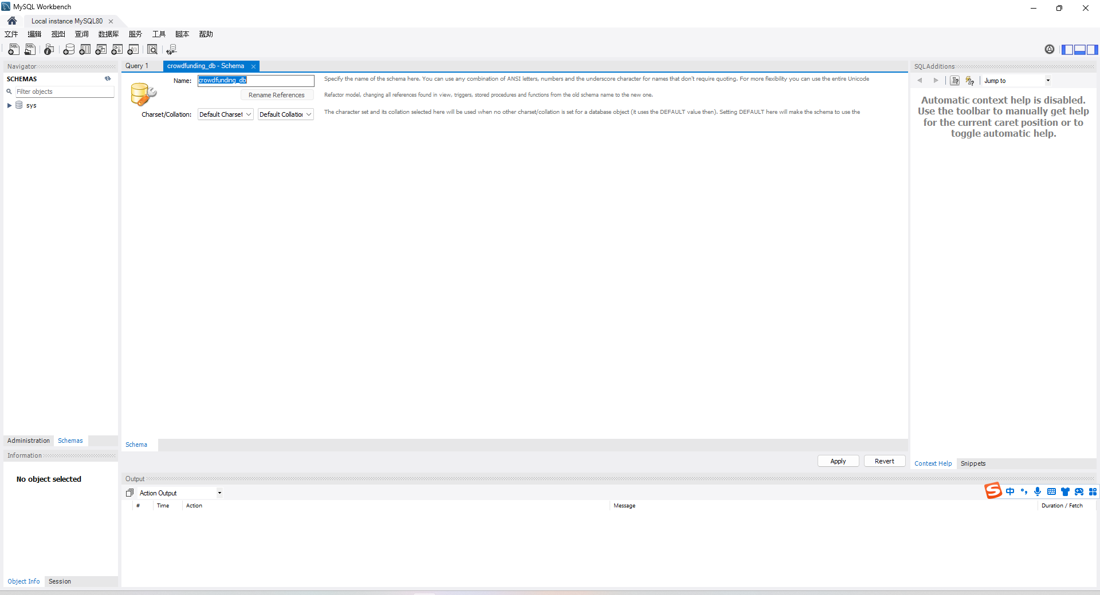

Part 1 Step 2. Create the FUNDRAISER table with the following fields of the CATEGORY table.

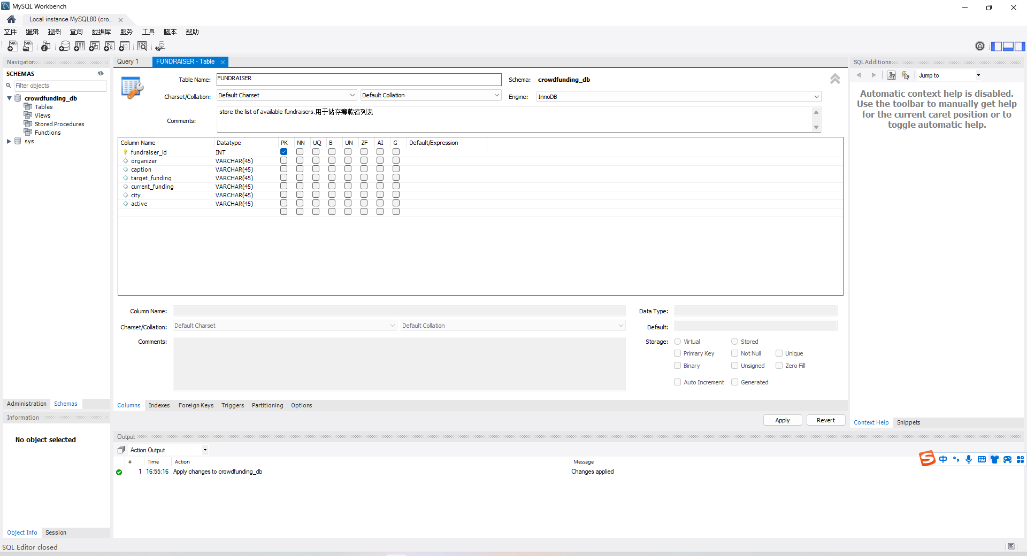

Part 1 Step 2. Each field modifies the appropriate data type.

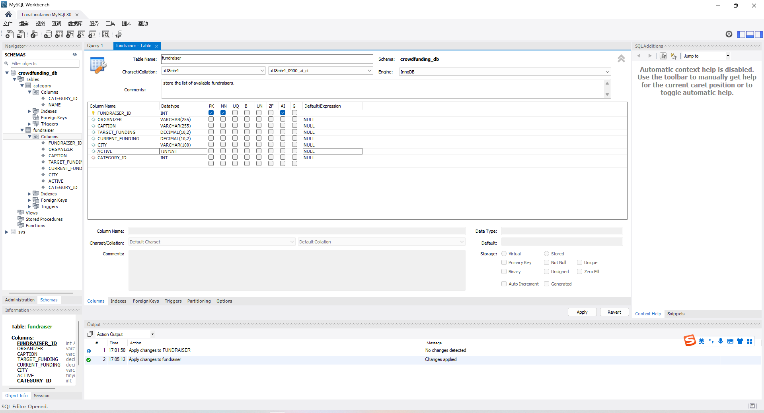

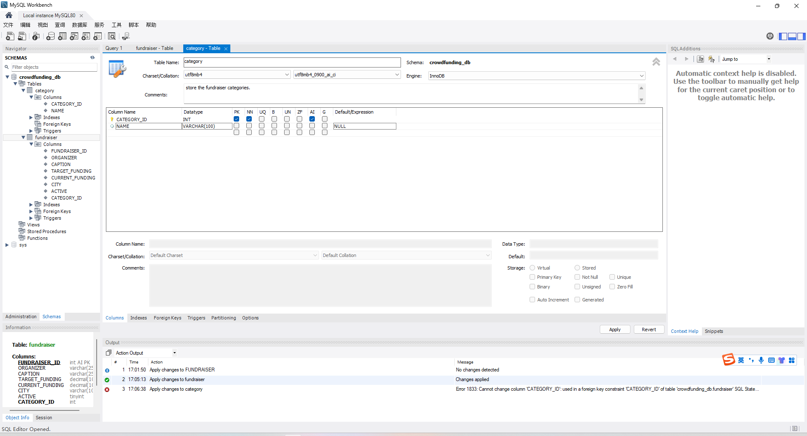

Part 1 Step 3. Insert at least 5 records into the FUNDRAISER table and at least 3 records into the CATEGORY table.

